Informatieboekje



"Bonding the World with Chemistry"

**49e INTERNATIONAL CHEMISTRY OLYMPIAD   
Nakhon Pathom, THAILAND**

**Constantes en formules**

constante van Avogadro, *N*A = 6,0221∙1023 mol–1

constante van Boltzmann, *k*B = 1,3807∙10–23 J K–1

gasconstante, *R =* 8,3145 J K–1 mol–1 **=** 0,08205 atm L K–1 mol–1

lichtsnelheid, *c =* 2,9979∙108 m s–1

constante van Planck, *h =* 6,6261∙10–34 J s

constante van Faraday, *F* = 9,64853399∙104 C

rustmassa elektron, *me* = 9,10938215∙10–31 kg

standaarddruk, *p*0 = 1 bar = 105 Pa

atmosferische druk, *p*atm = 1,01325∙105 Pa = 760 mmHg = 760 torr

0 oC = 273,15 K

1 picometer (pm) = 10–12 m; 1 Å = 10-10 m; nanometer (nm) *=* 10–9 m

1 eV = 1,6 ∙ 10-19 J

1 ame = 1,66053904 ∙ 10-27 kg

algemene gaswet: *PV* = *nRT*

enthalpie: *H* = *U* – *PV*

gibbs vrije energie: *G* = *H* – *TS* 



entropieverandering: , waarin *qrev* de warmteuitwisseling is bij het reversibele proces

 (bij een isotherme expansie van een ideaal gas)

wet van Nernst: 

energie van een foton: 

wet van Lambert-Beer: 

reactiesnelheid

nulde orde eerste orde 

tweede orde 

vergelijking van Arrhenius 

**Periodiek systeem**

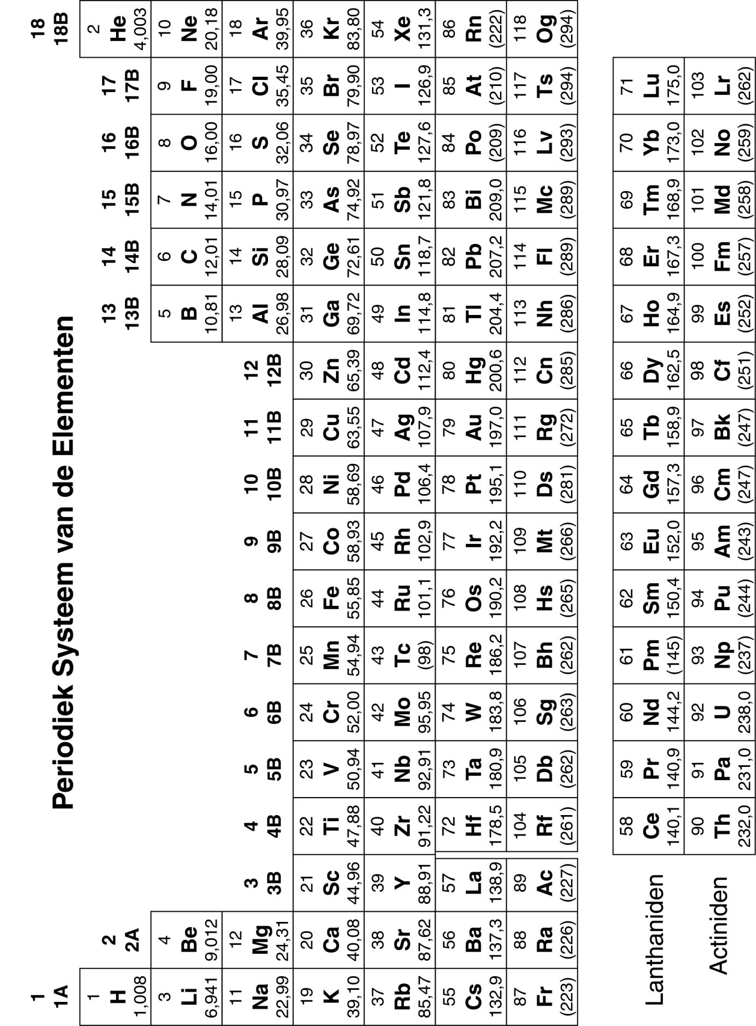



|  |  |  |  |  |
| --- | --- | --- | --- | --- |
| **Karakteristieke 1H NMR Chemical Shifts (= chemische verschuiving)** | | | | |
| **soort waterstofatoom (R=Alkyl, Ar=Aryl)** | **Chemical Shift (ppm)** |  | **soort waterstof-atoom (R=Alkyl, Ar=Aryl)** | **Chemical Shift (ppm)** |
| (CH3)4Si | 0 (per definitie) |  |  |  |
| RC**H**3 | 0,9 |  | RC**H**=O | 9,5-10,1 |
| RC**H**2R | 1,2-1,4 |  | RCOO**H'** | 10-13 |
| R3C**H** | 1,4-1,7 |  | RCOC**H**3 | 2,1-2,3 |
| RC**H**2I | 3,2-3,3 |  | RCOC**H**2R | 2,2-2,6 |
| RC**H**2Br | 3,4-3,5 |  | RCOOC**H**3 | 3,7-3,9 |
| RC**H**2Cl | 3,6-3,8 |  | RCOOC**H**2R | 4,1-4,7 |
| RC**H**2F | 4,4-4,5 |  | R2C=CRC**H**R2 | 1,6-2,6 |
| RC**H**2NH2 | 2,3-2,9 |  | R2C=C**H**2 | 4,6-5,0 |
| RC**H**2OH | 3,4-4,0 |  | R2C=C**H**R | 5,0-5,7 |
| RC**H**2OR | 3,3-4,0 |  | RC≡C**H** | 2,0-3,0 |
| RC**H**2CH2OR | 1,5-1,6 |  | ArC**H**3 | 2,2-2,5 |
| R2N**H** | 0,5-5,0 |  | ArC**H**2R | 2,3-2,8 |
| RO**H** | 0,5-6,0 |  | Ar**H** | 6,5-8,5 |

|  |  |  |  |  |
| --- | --- | --- | --- | --- |
| **Karakteristieke 13C NMR Chemical Shifts** | | | | |
| **soort koolstofatoom (R=Alkyl, Ar=Aryl)** | **Chemical Shift (ppm)** |  | **soort koolstofatoom (R=Alkyl, Ar=Aryl)** | **Chemical Shift (ppm)** |
| R**C**H3 | 10-25 |  | R**C**(drievoudige binding)CR | 65-85 |
| R**C**H2R | 20-35 |  | RCH=**C**HR | 120-140 |
| R3**C**H | 25-35 |  | Aryl**C** | 120-140 |
| R**C**H2COR | 35-50 |  | R**C**OOR | 160-180 |
| R**C**H2Br | 25-35 |  | R**C**ONR2 (amide) | 165-180 |
| R**C**H2Cl | 40-45 |  | R**C**OOH | 175-185 |
| R**C**H2NH2 | 30-65 |  | R**C**HO | 190-205 |
| R**C**H2OH | 60-70 |  | R**C**OR | 200-215 |
| R**C**H2OR | 65-70 |  |  |  |

*Afkomstig van RSC E-learning website*

**Tabel met IR absorptiefrequenties**

|  |  |  |  |  |  |  |
| --- | --- | --- | --- | --- | --- | --- |
| **karakteristieke IR absorptiefrequenties van organische functionele groepen** | | | | | | |
| **functionele groep** | | **type vibratie** | **karakteristieke absorptie (cm**‑**1)** | | **Intensiteit** | |
| **alcohol** | |  | | | | |
| O-H | | (strek, H-brug) | 3200-3600 | | sterk, breed | |
| O-H | | (strek, vrij) | 3500-3700 | | sterk, scherp | |
| C-O | | (strek) | 1050-1150 | | sterk | |
| **alkaan** | |  | | | | |
| C-H | | strek | 2850-3000 | | sterk | |
| -C-H | | buigen | 1350-1480 | | variabel | |
| **alkeen** | |  | | | | |
| =C-H | | strek | 3010-3100 | | middel | |
| =C-H | | buigen | 675-1000 | | sterk | |
| C=C | | strek | 1620-1680 | | variabel | |
| **halogeenalkaan** | |  | | | | |
| C-F | | strek | 1000-1400 | | sterk | |
| C-Cl | | strek | 600-800 | | sterk | |
| C-Br | | strek | 500-600 | | sterk | |
| C-I | | strek | 500 | | sterk | |
| **alkyn** | |  | | | | |
| C-H | | strek | 3300 | | sterk, scherp | |
| –C≡C– | | strek | 2100-2260 | | variabel, (vaak) niet aanwezig in symmetrische alkynen | |
| **amine** | |  | | | | |
| N-H | | strek | 3300-3500 | | middel (primaire amines hebben twee absorptiebanden; secundaire amines hebben er één, meestal heel zwak) | |
| C-N | | strek | 1080-1360 | | middel-zwak | |
| N-H | | buigen | 1600 | | middel | |
| **aromatisch** | |  | | | | |
| C-H | | strek | 3000-3100 | | middel | |
| C=C | | strek | 1400-1600 | | middel-zwak, meerdere banden | |
| analyse van C-H buig uit vlak (out-of-plane) kan vaak onderscheid maken in substitutiepatronen | | | | | | |
| **carbonyl** | |  | | | | |
| C=O | | strek | 1670-1820 | | sterk | |
| (conjugatie verschuift absorptie naar lagere frequenties) | | | | | | |
| **ether** | |  | | | | |
| C-O | | strek | 1000-1300 (1070-1150) | | sterk | |
| **nitril** | |  | | | | |
| CN | | strek | 2210-2260 | | middel | |
| **nitro** | |  | | | | |
| N-O | | strek | 1515-1560 & 1345-1385 | | sterk, twee absorptiebanden | |
| **IR absorptiefrequenties van functionele groepen die een carbonylgroep bevatten (C=O)** | | | | | | | |
| **functionele groep** | | **type vibratie** | | | **karakteristieke absorptie (cm**‑**1)** | | **intensiteit** |
| **carbonyl** | |  | | | | | |
| C=O | | strek | | | 1670-1820 | | sterk |
| (conjugatie verschuift absorptie naar lagere frequenties) | | | | | | | |
| **zuur** | |  | | | | | |
| C=O | | strek | | | 1700-1725 | | sterk |
| O-H | | strek | | | 2500-3300 | | sterk, heel breed |
| C-O | | strek | | | 1210-1320 | | sterk |
| **aldehyde** | |  | | | | | |
| C=O | | strek | | | 1740-1720 | | sterk |
| =C-H | | strek | | | 2820-2850 & 2720-2750 | | middel, twee pieken |
| **amide** | |  | | | | | |
| C=O | | strek | | | 1640-1690 | | sterk |
| N-H | | strek | | | 3100-3500 | | niet gesubstitueerde hebben twee absorptiebanden |
| N-H | | buigen | | | 1550-1640 | |  |
| **anhydride** | |  | | | | | |
| C=O | | strek | | | 1800-1830 & 1740-1775 | | twee absorptiebanden |
| **ester** | |  | | | | | |
| C=O | | strek | | | 1735-1750 | | sterk |
| C-O | | strek | | | 1000-1300 | | twee of meer absorptiebanden |
| **keton** | |  | | | | | |
| acyclisch | | strek | | | 1705-1725 | | sterk |
| cyclisch | | strek | | | 3-ring - 1850 4-ring - 1780 5-ring - 1745 6-ring - 1715 7-ring - 1705 | | sterk |
| ,-onverzadigd | | strek | | | 1665-1685 | | sterk |
| aryl keton | | strek | | | 1680-1700 | | sterk |

*Data afkomstig van* [*http://www2,ups,edu/faculty/hanson/Spectroscopy/IR/IRfrequencies,html*](http://www2.ups.edu/faculty/hanson/Spectroscopy/IR/IRfrequencies.html)